🔶 1. Why Java Is Called a Statically / Strictly Typed Language
Java is statically typed, meaning:

✔ The type of every variable must be known at compile time

✔ Before running the program, the compiler checks:
“Is this value allowed for this datatype?”
This checking is called:

⭐ TYPE CHECKING
If the value does not fit into the datatype → Compile Time Error.

🔶 2. What Exactly Does the Compiler Check? (IMPORTANT)
When Java sees a variable declaration:
byte b = 10;
Compiler performs 3 checks:

✔ Check 1: Is the value compatible with the datatype?
Example:
byte b = 130; // ❌ CE: possible lossy conversion
Why?
- byte range: -128 to 127
- 130 is outside the range → compiler stops the program.
👉 This is strict type checking.

✔ Check 2: Is the literal treated as int/ double by default?
Java always treats:
- whole numbers → int
- decimal numbers → double
So:
float f = 3.14; // ❌ CE: possible lossy conversion from double to float
The literal 3.14 is treated as double.
Fix:
float f = 3.14f; // ✔

✔ Check 3: Is the conversion widening or narrowing?

✔ Widening → allowed (no explicit cast)
small type → big type
Example:
int x = 10;
long y = x; // ✔ allowed

❌ Narrowing → requires explicit cast (because of strict typing)
big type → small type
Example:
int x = 130;
byte b = x; // ❌ CE unless cast is used
Correct way:
byte b = (byte)x; // ✔ but risk of data loss

🔶 3. Strict Typing Example That Confuses Beginners
byte a = 10;
byte b = 20;
byte c = a + b; // ❌ CE: cannot convert from int to byte
Why error?
Because a + b is an expression, and ALL integer expressions are automatically int.
So:
- a (byte)
- b (byte)
- a + b → int
Fix:
byte c = (byte)(a + b); // ✔ explicit cast
This is exactly what statically typed checking does —
even if the output fits in byte, compiler will NOT take the risk.

🔶 4. More Depth: Why Integer Expressions Become int?
According to Java Language Specification (JLS):
✔ Any operation on byte, short, char → result becomes int
This rule ensures:
- predictable results
- avoids overflow surprises
- simplifies JVM design
Example:
char c1 = 'A'; // 65
char c2 = 'B'; // 66
int result = c1 + c2; // 131
Result is always int.

🔶 5. Type Checking in Floating Points
double d = 10; // allowed → widening (int to double)
float f = 10.5; // ❌ double → float (narrowing)
Fix:
float f = 10.5f;
Because:
- float is 4 bytes
- double is 8 bytes
- compiler prevents precision loss

🔶 6. Type Checking in Boolean
Boolean is the strictest type in Java.
✔ Only true or false allowed
✔ No numeric conversions
✔ No automatic type promotion
Invalid:
boolean b = 1; // ❌
boolean b = 0; // ❌
boolean b = "true"; // ❌
Valid:
boolean b = true;
Java made boolean strict to avoid C-language style bugs where 0 = false, nonzero = true.

🔶 7. Type Checking in char (UNICODE)
Char is 2 bytes (not 1 byte like C).
char c = 97; // ✔ prints: 'a'
But:
char c = -1; // ❌ negative values not allowed
Because Unicode ranges from 0 to 65535.

🔶 8. Decimal Type Checking – VERY IMPORTANT
Example:
double d = 23 / 2;
System.out.println(d);
Output: 11.0
Why?
Because:
- 23 and 2 → both int
- int/int = int
- then converted to double
So fix:
double d = 23 / 2.0;
Or:
double d = (double)23 / 2;

🔶 9. Division With 0 — Type Checking Behavior
Example:
System.out.println(10 / 0);
❌ Runtime error: ArithmeticException
(compiler allows but JVM fails)
But:
System.out.println(10.0 / 0);
✔ Output: Infinity
(Java follows IEEE 754 floating rules)
And:
System.out.println(0.0 / 0);
✔ Output: NaN (Not a Number)
Very important for interviews.

🔶 10. Default Values and Type Checking
Default values apply only to instance and static variables, not local variables.

class Test {
int x;
boolean b;
public void local_Var(){
int y = 0;
}

public static void main(String[] args) {
Test t = new Test();
System.out.println(t.x); // 0
System.out.println(t.b); // false
System.out.println(t.y); // Compile time error

}
}

🔶 11. Complete Example Showing Type Checking
public class TypeCheckingDemo {
public static void main(String[] args) {

// 1. byte literal check
byte a = 127; // ✔
// byte b = 128; // ❌ CE

// 2. integer expression promotion
byte x = 10, y = 20;
// byte z = x + y; // ❌ int result
byte z = (byte)(x + y); // ✔

// 3. float/double check
// float f = 10.5; // ❌
float f = 10.5f; // ✔

// 4. boolean strictness
// boolean flag = 1; // ❌
boolean flag = true; // ✔

// 5. char range
char c = 65; // ✔ 'A'
// char d = -1; // ❌ out of range
}
}

❤️ FINAL CONCLUSION (VERY SIMPLE)
Type checking = Compiler making sure your value matches the datatype before running the program.
If anything does not match → compile time error.

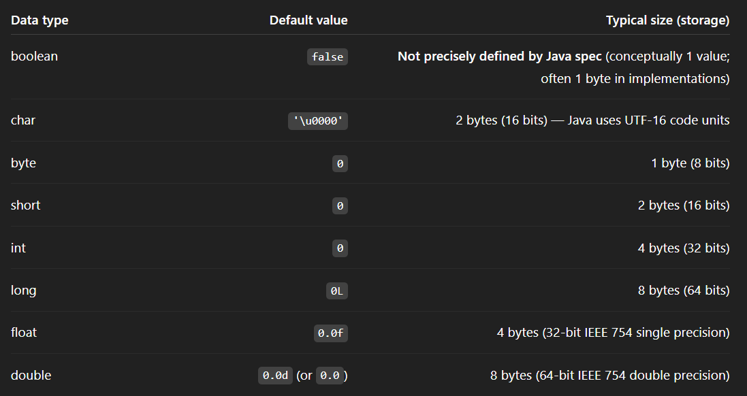

'\u0000' is the null character
- It is the Unicode character with code point 0.
- It is written as \u0000.
- It means “no character”, not the text "null".
char c = '\u0000';
System.out.println("A" + c + "B");

Eg: Char_To_Int
// go through the code

Eg: Division_With_Double_DataType

🟦 MASTER NOTES: DIVISION BEHAVIOR IN JAVA (int, long, float, double)

🟩 1. INTEGER DIVISION RULES
(Applies to int and long)

🟨 1.1 Normal integer division (non-zero)
- Truncates decimal part
- Only whole number result appears

✅ Example
5 / 2 = 2
10L / 3L = 3

🟥 1.2 Integer division by zero → ERROR

❌ Integer division by 0 throws:
ArithmeticException: / by zero

Why?
- Integer arithmetic cannot represent ∞ or NaN
- So Java throws exception

❌ Examples
5 / 0 → ArithmeticException
10L / 0L → ArithmeticException
0 / 0 → ArithmeticException
0L / 0L → ArithmeticException

🟦 CONCEPT: Zero Divided by an Integer (int or long)
When the numerator is 0 and the denominator is any non-zero int or long, Java uses integer division rules because both operands are integers.

🟩 1. Integer Division Concept (when numerator = 0)

✔ Rule:
0 ÷ (any non-zero integer) = 0

Why?
- In integer arithmetic, division means:
How many whole times does the denominator fit into the numerator?
- Example:
- 3 cannot fit even once inside 0 → answer is 0
So:

✔ 0 / 1 = 0

✔ 0 / 2 = 0

✔ 0 / 100 = 0

✔ 0 / 999999 = 0

✔ 0L / 5 = 0

✔ 0L / 500L = 0

🟥 2. When do you get an exception?
Only when the denominator is 0:
0 / 0 → Exception
10 / 0 → Exception
0L / 0L → Exception
Because integer division by zero is illegal.

🟦 3. General Formula for int and long
If:
numerator = 0
denominator = any integer except 0
Then:
result = 0

🟩 4. Summary (Perfect One-Liner)

👉 Zero divided by any non-zero int or long always gives 0, because integer division counts whole times the denominator fits into the numerator — and 0 cannot contain any whole unit.

🟦 CONCEPT: Zero Divided by an Integer (int or long)
When the numerator is 0 and the denominator is any non-zero int or long, Java uses integer division rules because both operands are integers.

🟩 1. Integer Division Concept (when numerator = 0)

✔ Rule:
0 ÷ (any non-zero integer) = 0

Why?
- In integer arithmetic, division means:
How many whole times does the denominator fit into the numerator?
- Example:
- 3 cannot fit even once inside 0 → answer is 0
So:

✔ 0 / 1 = 0

✔ 0 / 2 = 0

✔ 0 / 100 = 0

✔ 0 / 999999 = 0

✔ 0L / 5 = 0

✔ 0L / 500L = 0

🟥 2. When do you get an exception?
Only when the denominator is 0:
0 / 0 → Exception
10 / 0 → Exception
0L / 0L → Exception
Because integer division by zero is illegal.

🟦 3. General Formula for int and long
If:
numerator = 0
denominator = any integer except 0
Then:
result = 0

🟩 4. Summary (Perfect One-Liner)

👉 Zero divided by any non-zero int or long always gives 0, because integer division counts whole times the denominator fits into the numerator — and 0 cannot contain any whole unit.

